**PRACTICAL**

Install MySQL to configure database server, Install phpMyAdmin to operate MySQL on web browser from Clients.

To install the MySQL database server, run



Once installed, the MySQL server will be automatically started. You can check its status with

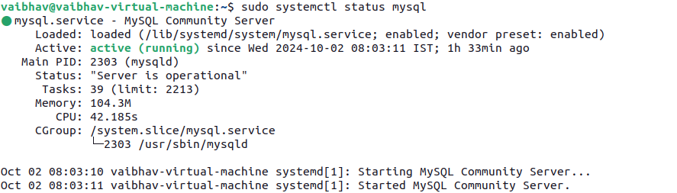

After the installation, you should secure MySQL by running the security script



This will prompt you to:

* Set the root password.
* Remove anonymous users.
* Disallow root login remotely.
* Remove test databases.
* Reload privilege tables.

Log in as the root user

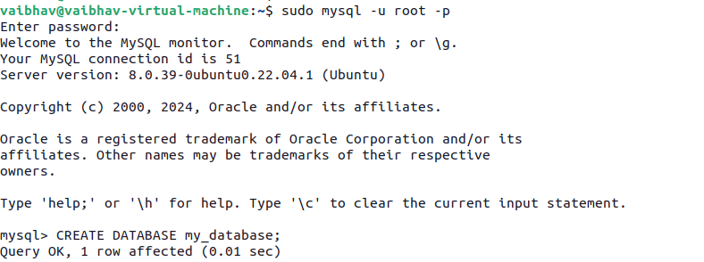

create a database and user that phpMyAdmin will manage







To use phpMyAdmin, you need a web server like Apache

Install phpMyAdmin, a web interface to manage your MySQL databases.



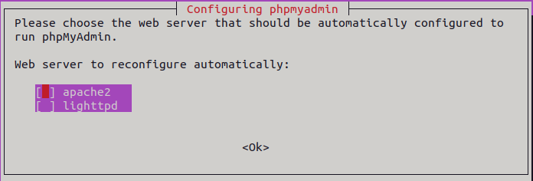

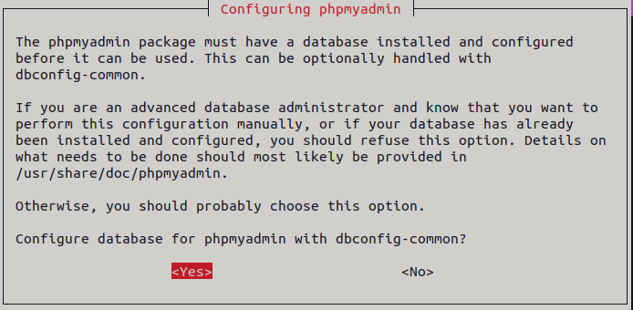

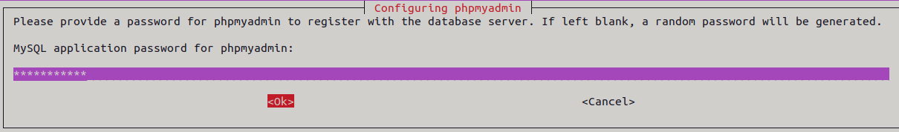

Link phpMyAdmin to Apache



Enable phpmyadmin conf



Restart service



You can now access phpMyAdmin from your web browser by navigating to

